**Summing Amplifier**

Introduction:

Summing amplifier is a type of operational amplifier (Op-Amp) circuit that can be used to add multiple input signals and generate only single output voltage. The summing amplifier is a non-inverting amplifier with multiple inputs, each of which has its own input resistor. This resistor provides a voltage-to-current conversion for each input signal. The summing amplifier is a useful circuit for combining signals and is used in various applications like audio mixing, instrumentation, and data acquisition.

Circuit Diagram:

The circuit diagram of a summing amplifier is straightforward. It consists of an operational amplifier, multiple input resistors, and a feedback resistor. The operational amplifier used in the circuit is usually a high-gain, high-input impedance device with a low output impedance.

The circuit diagram of the summing amplifier is shown below:

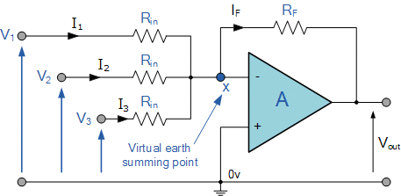

In the circuit, each input signal (V1, V2, V3,...,Vn) is connect to its own input resistor (R1, R2, R3,...,Rn), which is then connected to the non inverting input of the operational amplifier. The feedback resistor (Rf) is connected between the output of the amplifier and the inverting input.

Working Principle:

The summing amplifier circuit works on the principle of virtual ground. The input resistors are used to convert the input voltages into currents, which are then summed at the non-inverting input of the operational amplifier. The feedback resistor is used to set the gain of the amplifier.

When a input voltage is applied to non-inverting input of the operational amplifier, the output of the amplifier changes to maintain the voltage at the non-inverting input equal to the voltage at the inverting input. In the case of the summing amplifier, the non-inverting input is at virtual ground. Therefore, the voltage at inverting input is equal to the weighted sum of input voltages.

The output voltage of the amplifier is given by the formula:

Vo = -(Rf/R1 * V1 + Rf/R2 * V2 + Rf/R3 * V3 + … + Rf/Rn * Vn)

Negative sign in formula is due to the fact that amplifier is a non-inverting amplifier. The gain of the amplifier is given by the formula:

G = -Rf/R1 + Rf/R2 + Rf/R3 + … + Rf/Rn

Applications:

The summing amplifier circuit has various applications in electronics. Some of the significant applications are:

1. Audio mixing: In audio mixing applications, the summing amplifier is used to combine multiple audio signals to produce a single output signal.

2. Data acquisition: In data acquisition systems, the summing amplifier is used to add multiple sensor signals and generate a single output signal.

3. Instrumentation: In instrumentation applications, the summing amplifier is used to add multiple signals from different sensors and generate a single output signal.

Advantages:

1. The summing amplifier is a simple and cost-effective circuit that can be easily implemented.

2. It provides a convenient way of combining multiple input signals.

3. The summing amplifier can handle both AC and DC signals.

Disadvantages:

1. The summing amplifier requires precise resistor values to achieve accurate summing.

2. The circuit can be sensitive to noise and interference.

Conclusion:

In conclusion, the summing amplifier is a useful circuit for combining multiple input signals. The circuit is widely used in various applications like audio mixing, instrumentation, and data acquisition. The circuit is simple and cost-effective and can handle both AC and DC signals. However, the circuit requires precise resistor values to achieve accurate summing and can be sensitive